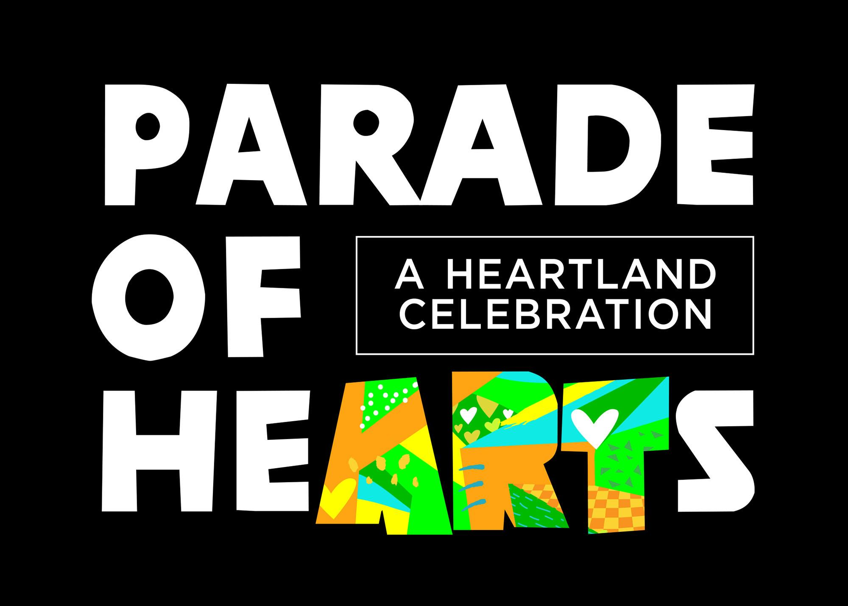™

Parade of Hearts 2023 - Guidelines & Copyright

Lots of excitement is coming to the Kansas City region in 2023 including one of the biggest and most-anticipated professional sporting events our city has hosted. Visitors from around the country will be traveling to experience Kansas City and the region. Millions of viewers will see our town in the national spotlight on major networks. So, we are having a Limited Edition Parade of Hearts to join in on the fun. Approximately 40 beautifully decorated hearts will be displayed in high traffic visitor areas and then spread throughout the City.

When?
The hearts will go ‘on parade’ in April 2023 and will remain on display in predetermined locations. In May, the hearts will be moved to a variety of locations and will remain there until mid-July. Then we’ll round them up for auction. See projected schedule below (subject to change).

10.26.22 - Artist Design Submission Begins
11.30.22 - Artist Design Submission Ends
12.15.22 - Notification of Artists Selected
12.20.22 - First date Artists can pick up their blank heart
3.18.23 - 3.25.23 - Finished hearts delivered to POH warehouse by Artists
4.14.23 - Installation of hearts in public begins
7.15.23 - Public art experience ends

Who?
The Parade of Hearts 2023 & 2024 will benefit: Arts & Culture (Local & Regional Artist community), Health & Wellness (University of Kansas Health System and Children's Miracle Network Hospitals).
Public charities throughout the KC region will have a chance to submit an application for consideration to become the third beneficiary for Parade of Hearts. A selection committee will review applications and choose the third beneficiary that will be announced in early 2023.

Production of the Hearts
Once an artist is selected by an independent juried panel to participate in this exclusive mini parade, each artist will pick up their five-foot, blank fiberglass heart form and will be mailed a $1,000 check towards their $2,000 honorarium. Once completed and returned, artists will receive the final $1,000. Artists can work on the heart in your own studio or space.

Please note: Artists are responsible to pick up and deliver your heart to a designated location.

Selection Process
- Artists may be selected by sponsors to produce up to one (1) design and will be paid an honorarium of $2,000.
- Once the application has been submitted it will be reviewed by a Jury panel composed of representatives selected by POH. The Panel will ensure that designs conform to the standards outlined above. If your design is not approved by the Panel, you will be notified.
- Following approval by the POH Jury Art panel, the POH sponsors will then review the designs for selection. Some sponsors may select designs from among these submissions.
- Once a design has been selected for production by a sponsor, the artist will be notified immediately. Artists should keep in mind that sponsors will be reviewing design applications on an on-going basis throughout the process.
- Once a heart design has been selected the Artist will enter into an Agreement with POH for the design, fabrication, installation and removal of the artwork for the 2023 Parade of Hearts Event.
- Based on the Agreement between the Artist and POH, POH will retain exclusive ownership of the artwork created and the Artists will retain ownership in the copyright of the artwork and will execute an exclusive copyright license with POH for the copyright of the artwork.
- NOTE: If your heart design is not approved for evaluation and consideration, or it is not selected for exhibition in the 2023 Parade of Hearts event, Parade of Hearts shall assign the entire right, title, and interest in your design back to you.

Selection Criteria
- All proposals will be evaluated on the following:
1) Artistic merit and innovative thinking
2) Appropriateness of work for a public/community setting
3) Heart must be picked up, completed, and returned in the provided schedule
4) Expressed interest in and understanding of the project
5) The proposal’s compliance with the goals and conditions of the project
6) You have agreed to, and signed, and returned the Artist Copyright Agreement
7) To the extent anyone else contributes to your design, they are required to provide by written agreement an assignment of their copyright in the contribution to Parade of Hearts.

Artistic Designs
- The artist may paint, sculpt, transform, and adorn the heart as he or she wishes, but the structural integrity of the heart must not be compromised, and the mechanisms for attaching the heart to its fiberglass base should not be altered or obstructed.
- Kansas City-related themes are appropriate and unique interpretations of this subject are encouraged.

Design Submission:
Artists should bear in mind that the audience will be broad-based and of all ages, and designs should be appropriate for public display. Each artist is allowed to submit ONE design. Design should reflect the planned execution. Minor changes are allowed with approval (we understand you may want to modify once you have possession of the heart and we want you to make the design the best it can be). Keep in mind that your design if selected was chosen over other designs, so Major changes will not be accepted.

Other Guidelines
- “KC letters” - will be recessed and located on one side of the heart only. It does not necessarily need to be part of the design, but it can be the focus if you’d like. We are KC!
- Both the front and rear faces need to be incorporated into the design submission. The final execution of the heart will need to have the sides and base addressed and finished. This can be a solid color or a design element tying everything together. The base will be stood on, climbed on, etc. and it will include a plaque with the Title, Sponsor Name, and Artist Name. It will be located on the right side of the base, below the KC. Please do not apply design elements that might affect the placement of the plaque.
- The basic heart may be altered by the artist, so long as it remains structurally intact. Once your design is selected and approved, any changes must be sent for approval to POH.
- Power - hearts will not have access to power while they’re on public display.
- Artists should bear in mind that the audience will be broad-based and of all ages, and designs should be appropriate for public display. Designs that are religious, political, or sexual in nature will not be accepted. Additionally, neither corporate logos nor advertising is allowed in the design. As outlined below, designs will be evaluated by a review panel to ensure they conform to these guidelines. The review panel may reject any design that, in its sole discretion, does not adhere to these guidelines.

The Details

Heart Form Specifications
The 2023 Parade of Hearts series will include:

Large Heart Sculptures:
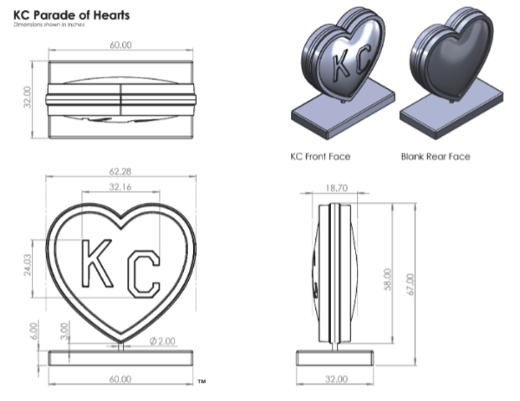

- The Heart Sculptures are manufactured using a mixture of DCDP Laminating Resin and chopped strand mat fiberglass reinforcement over an initial polyester gel spray coat. Several layers of chopped strand matting fiberglass are hand laid, wetted with laminating resin to the point of full saturation. Steel structural elements are secured with a fiberglass roving/resin mixture where applicable. Steel is placed at specific stress points.
- Fiberglass: 1½ ounce chopped strand mat (CSM), e-glass
- Mold Release: Mold release wax, PVA Internal Rebars: Steel structure
- Gelcoat: White base polyester gelcoat
- Resin: DCPD polyester laminating resin
- Seaming Materials: Plexus structural adhesive
- Filler: Fume silica
- Primer: 100% Acrylic White
- Topcoat: No
- Heart Sculptures will arrive primed and on a base.
- Steel is placed at specific stress points such as through the middle of the heart/base
- The basic heart may be altered by the artist, so long as it remains structurally intact.

Paints, Topcoats and Weatherproofing

Hearts will be placed in areas fully accessible to the public. Although a few hearts may be in indoor locations, most will be outdoors. In creating a design, please consider carefully the weather and other elements of nature, including sun, rain, wind, and dirt. We cannot guarantee whether a given heart can be placed indoors or in a weather-protected location. Please design for outdoor placement.

Additionally, Parade of Hearts 2023 is an interactive event that allows the public to touch and feel the designs. As such, designs should be created with durability and public safety concerns in mind.

Although objects may be attached to the hearts, artists should be aware that vandalism can occur. Any object added to a heart should be attached in such a way that it cannot be easily removed. If vandalism should occur, please make sure objects can be easily duplicated/replaced.

The surface of each heart is primed by the manufacturer. Unless you have altered the exterior of your heart, you will not need to reapply a primer. Acrylic paint, artificial resin paint or two-component paint can be used to paint the hearts.

POH will apply the clear coat finish. Please do not apply a final clear coat. Reach out to us with any questions about the clear coat.

When placed in public, the hearts will be affixed to fiberglass bases with hidden sandbags, weighing approximately 375 pounds.

Construction Recommendations and Requirements
Medium
Acrylic paints are recommended and normally used in these types of displays. However, you are not restricted to acrylic paints. Oil paints will take too long to dry. All mediums will be considered in the selection process.

Use of papier-mâché as a medium is not allowed.

Constructing a sculpture using another medium, must be pre-authorized and approved by POH.

Design Elements
No corporate logo of any kind can be integrated into the Heart Sculpture design and artwork. Artists may decorate the base of the Heart Sculpture, but POH will attach a plaque after completion. Design and artwork must not impact the stability and sturdiness of the Heart Sculpture.

PLEASE NOTE: You are expected to execute the design you submitted, using the mediums submitted. Any design changes made to the sculpture that differ from the submission must be provided to the POH for approval.

Cutting
Any holes or punctures made into the Heart Sculpture must be pre-approved by POH during the application process.

The best method for cutting the Heart Sculpture is to use a reciprocating saw (i.e. pneumatic or electric jig saw). Drilling may be required to allow access for the blade, depending on location of the cut. Carbon or high-speed steel bits and blades should be used in case the structural steel is hit (the Heart Sculpture is hollow but has steel rebars). Extensive cutting of fiberglass will dull blades. All holes should be filled after use and completely sealed along the edges (with an epoxy of two-part resin and cloth) to prevent warping, peeling, and other deterioration of the fiberglass layers.

Finishing
Seams can be filled using a mixture of the resin and powdered silica (Cab-O-Sil) or automotive filler such as Bondo. Allow ample time to cure before sanding. A light coat of primer on the area reveals imperfections. Repeat the fill and sand procedure until all are filled. Spot putty can be used for pinholes and scratches. All openings must be sealed back up to prevent weather elements, rodents, and any other foreign objects from getting inside.

Final Coats
Heart Sculptures will be properly varnished/coated to avoid weather damage. POH will handle clear coating of all hearts.

Repair of Hearts
Artists will not be responsible for the installation, removal, or touch-ups of the hearts, Parade of Hearts will manage this process.
- POH plans to hire a few POH artists that will handle touch-ups during the public art experience.
- POH would like the artists to supply detailed information about specific materials used in their design along with advice on how to repair, if needed.
- If an artist would like to handle their own touch-ups on their own time, POH will evaluate based on the artist’s schedule availability.

COPYRIGHT LICENSE AGREEMENT – PARADE OF HEARTS
By submitting a 2023 Parade of Hearts Artist Application to Parade of Hearts LLC (“Parade of Hearts”) for evaluation and consideration in the 2023 Parade of Hearts Event (“Event”), each author, owner, or artist (“Artist”) of the Work agrees to the following:

1. In accordance with the requirements of the 2023 Parade of Hearts Artist Application Guidelines, and as consideration for acceptance of the heart design submitted by Artist (“Work”) for evaluation and consideration by Parade of Hearts for inclusion in the 2023 Parade of Hearts Event, and any resulting monetary and non-monetary benefits to Artist by their involvement in the 2023 Parade of Hearts Event, Artist hereby grants and agrees to grant to Parade of Hearts and its affiliates during the Event and for a time after the Event an exclusive, right and license to use, reproduce, publicly perform, display, transmit, profit from, and distribute the Work, including translate, alter, modify, and create derivative works of the Work, including as to any additional authorship of the Work, in any and all media whether now or hereafter known or devised and by any and all technologies and means of delivery whether now or hereafter known or devised.
2. Parade of Hearts will have and retain exclusive ownership of, and title to, the item or work of visual art created by the Artist representing the Work (the “Article”).
3. The Artist will retain ownership in the copyright for the Work in accordance with this Copyright License Agreement and a subsequent Agreement provided upon acceptance of the Work by Parade of Hearts.
4. Artist agrees to provide to Parade of Hearts, written, absolute, irrevocable waiver, in favor of Parade of Hearts, from each individual who is an author (sole or joint) of any of the Work or Article.
5. If Artist’s Work is accepted, Artist agrees to execute an Agreement as provided by Parade of Hearts for the Event.
6. The term of this agreement commences upon submission of the Parade of Hearts Artist Application from the Artist to participate in the 2023 Parade of Hearts and will remain in force until the Work is accepted or rejected for the Event. If the Work is rejected for the event this Copyright License Agreement ends at the time of rejection. If the Work is accepted the Artist will enter into an Agreement for the Parade of Hearts Event, if an Agreement between the Artist and Parade of Hearts cannot be reached the Work will then be rejected by Parade of Hearts and this Copyright License Agreement will end.
7. Artist confirms the Work is original to the author(s), has not copied anyone else’s work, and the Work does not infringe any other work.
8. Artist warrants to Parade of Hearts that it has the full right, power, and authority to enter into this agreement and to perform its obligations and has and will not grant during the Event any encumbrances in, to, or under the Work.
9. Artist agrees to not assign, license, or reproduce the same Work or same Article to or for a third party if the Work is accepted for inclusion in the Parade of Hearts Event written permission of Parade of Hearts.
10. This agreement shall be binding upon and shall inure to the benefit of the parties hereto and their respective successors and assigns.
11. Artist agrees to take the steps necessary to affect this agreement.

